Internship Project Title | Rank features of smartphone build a python application to classify and rank dataset
Name of the Company
Name of the Industry Mentor
Name of the Institute | ICT ACADEMY OF KERALA

Start Date | End Date |  | Total Effort (hrs.) |  | Project Environment | Tools used
04/02/2023 | 09/02/2023 |  | 21 |  | PYTHON | PANDAS ,NUMPY
Milestone # | 1 | Milestone: |  | 2

Objective:
The objective of this project is to create a Python application that collects feature requests made by the user community for a particular smartphone. The application should also rank the user requests from most popular to least popular. We aim to achieve this by creating a dataset of 200,000 entries using the Pandas library containing the following details of various feature requests made by users: User ID, Type of Feature, Type of Hardware, Type of Software, and Brief Description.

Introduction / Description of Internship:
The smartphone market is highly competitive, and customers are always looking for the latest and greatest features in their phones. Therefore, it is crucial for smartphone manufacturers to keep up with user demands and add new features to their devices continually. This project aims to build a Python application that can help smartphone manufacturers collect user feature requests and rank them according to their popularity.

Internship Activities:
- Data collection: We will create a dataset of 200,000 entries using the Pandas library containing the following details of various feature requests made by users: User ID, Type of Feature, Type of Hardware, Type of Software, and Brief Description.
- Data preprocessing: We will use label encoding to convert categorical data into numerical data and split the data into two different dataframes containing hardware and software requests.
- Model building: We will use linear regression, decision tree, and random forest algorithms to build models on the training datasets. We will also use feature extraction techniques like PCA, LDA, and t-SNE to reduce the dimensions of the data and apply clustering techniques like k-means and hierarchical clustering to group the data points into clusters based on their similarity. Finally, we will use sentiment analysis techniques to classify the user requests based on their sentiment (positive, negative, or neutral).
- Merging the classified datasets: We will merge the classified hardware and software datasets and rank the final dataset based on the popularity of the feature requests.

Methodology

LABEL ENCODING: Label Encoding is a process of converting categorical data into numerical data. In Python, it can be achieved using the LabelEncoder class from the scikit-learn library.
LINEAR REGRESSION :Linear Regression is a statistical method used to model the relationship between a dependent variable and one or more independent variables. It is used to predict a continuous outcome variable (dependent variable) based on one or more predictor variables (independent variables).In Python, we can implement linear regression using scikit-learn library
DECISON TREE CLASSIFIER:Decision Tree Classifier is a popular machine learning algorithm used for classification tasks. It works by creating a tree-like model of decisions and their possible consequences. In Python, we can implement the Decision Tree Classifier using the scikit-learn library.
RANDOM FOREST:Decision Tree Classifier is a popular machine learning algorithm used for classification tasks. It works by creating a tree-like model of decisions and their possible consequences. In Python, we can implement the Decision Tree Classifier using the scikit-learn library.
PRINCIPAL COMPONENT ANALYSIS:Principal Component Analysis (PCA) is a popular technique used for reducing the dimensionality of a dataset by identifying the most important variables. It is used to identify patterns and relationships in data, and is often used in exploratory data analysis, visualization, and machine learning.In Python, we can implement PCA using the scikit-learn library

Linear Discriminant Analysis (LDA):It is a statistical technique used for supervised classification problems, where the goal is to predict the class of an observation based on its set of predictors or features.
In LDA, the goal is to find a linear combination of the features that maximally separates the classes in the data. This is done by computing the means and covariance matrices of the feature variables for each class, and then finding the linear discriminant function that best separates the classes.
The discriminant function can be used to classify new observations by computing their scores on the function and assigning them to the class with the highest score.
LDA has several applications, including in image recognition, face recognition, and gene expression analysis, among others. It is also closely related to other techniques such as Principal Component Analysis (PCA) and Canonical Correlation Analysis (CCA).

K-MEANS:K-Means is a clustering algorithm used in unsupervised learning to partition a given dataset into K clusters. The algorithm works by iteratively assigning each data point to the closest cluster centroid, and then updating the centroid to be the mean of all the points assigned to that cluster. The process is repeated until convergence, which is reached when the assignments no longer change.
The K-Means algorithm requires the specification of the number of clusters (K) as a hyperparameter. It can be sensitive to the initial placement of the centroids, so it is common practice to run the algorithm multiple times with different initializations and choose the result with the lowest sum of squared distances from the centroids to the data points (also known as the "inertia").
K-Means is a widely used clustering algorithm due to its simplicity and efficiency. It has applications in image segmentation, customer segmentation, and anomaly detection, among others. However, it may not perform well on data with non-linear boundaries or varying cluster densities. In these cases, more complex clustering algorithms such as hierarchical clustering or DBSCAN may be more appropriate.

SENTIMENT ANALYSIS:Sentiment analysis, also known as opinion mining, is a natural language processing technique used to determine the sentiment (positive, negative, or neutral) expressed in a piece of text such as a review, tweet, or comment.
The process of sentiment analysis involves several steps. First, the text is preprocessed to remove stop words, punctuation, and other irrelevant information. Then, a sentiment lexicon or machine learning algorithm is used to classify the text as positive, negative, or neutral.
Sentiment lexicons are pre-built dictionaries or lists of words and their associated sentiment scores. Machine learning algorithms, on the other hand, learn to classify sentiment by training on labeled data.
Sentiment analysis has many applications, including in product and service reviews, social media monitoring, and market research. It can help businesses understand customer sentiment and make data-driven decisions based on customer feedback. However, it can be challenging to achieve high accuracy in sentiment analysis, especially when dealing with sarcasm, irony, and other forms of figurative language.

EXPLORATORY DATA ANALYSIS

Countplot of each column from the dataset

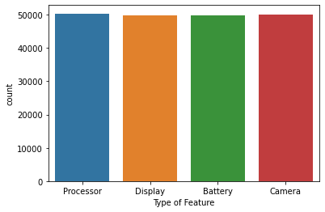

Fig:1-countplot for type of feature

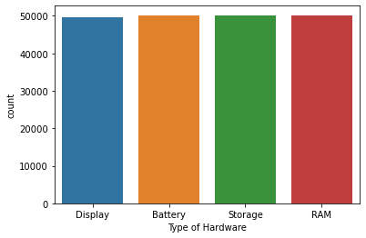

Fig:2-countplot for type of hardware

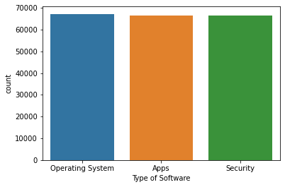

Fig:3-countplot for type of software

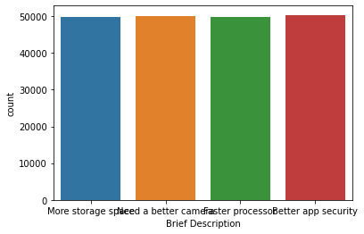

Fig:4-countplot for breif description

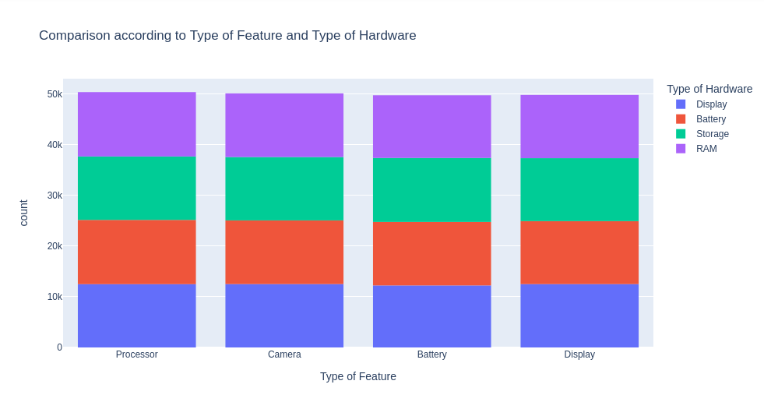
Fig:5-comparison histogram for type of feature vs type of hardware

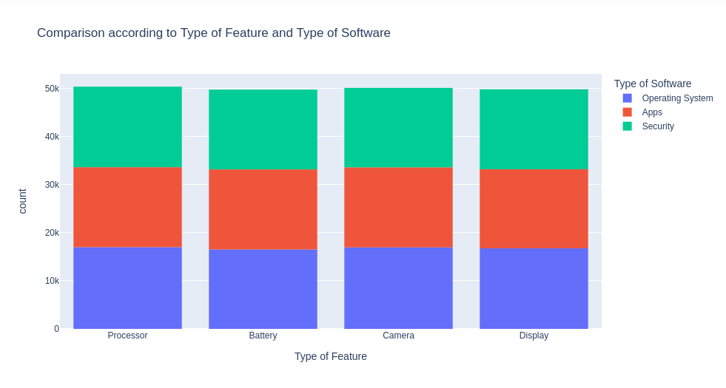
Fig:6-comparison histogram for type of feature vs type of software

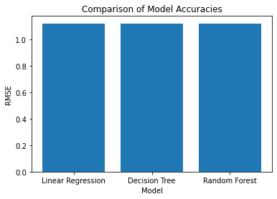

Fig:7-comparison histogram of model accuracies
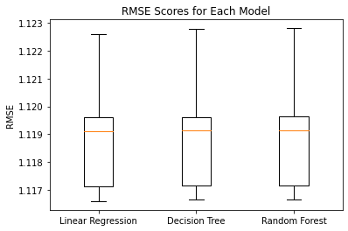

Fig:8-comparison boxplot for RMSE Scores of each model

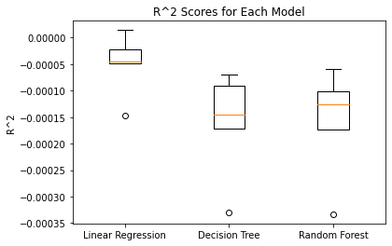

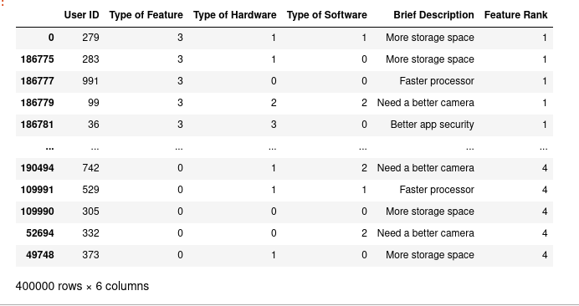
Fig:9-rank wise dataset
CONCLUSION:
we developed a Python application that collects feature requests made by the user community for a particular smartphone. The application should also rank the user requests from most popular to least popular. We aim to achieve this by creating a dataset of 200,000 entries using the Pandas library containing the following details of various feature requests made by users: User ID, Type of Feature, Type of Hardware, Type of Software, and Brief Description. Here we used linear regression, decision tree, and random forest algorithms to build models on the training datasets. use feature extraction techniques like PCA, LDA,o reduce the dimensions of the data and apply clustering techniques like k-means to group the data points into clusters based on their similarity. Finally, we used sentiment analysis techniques to classify the user requests based on their sentiment (positive, negative, or neutral).merge the classified hardware and software datasets and rank the final dataset based on the popularity of the feature requests.

